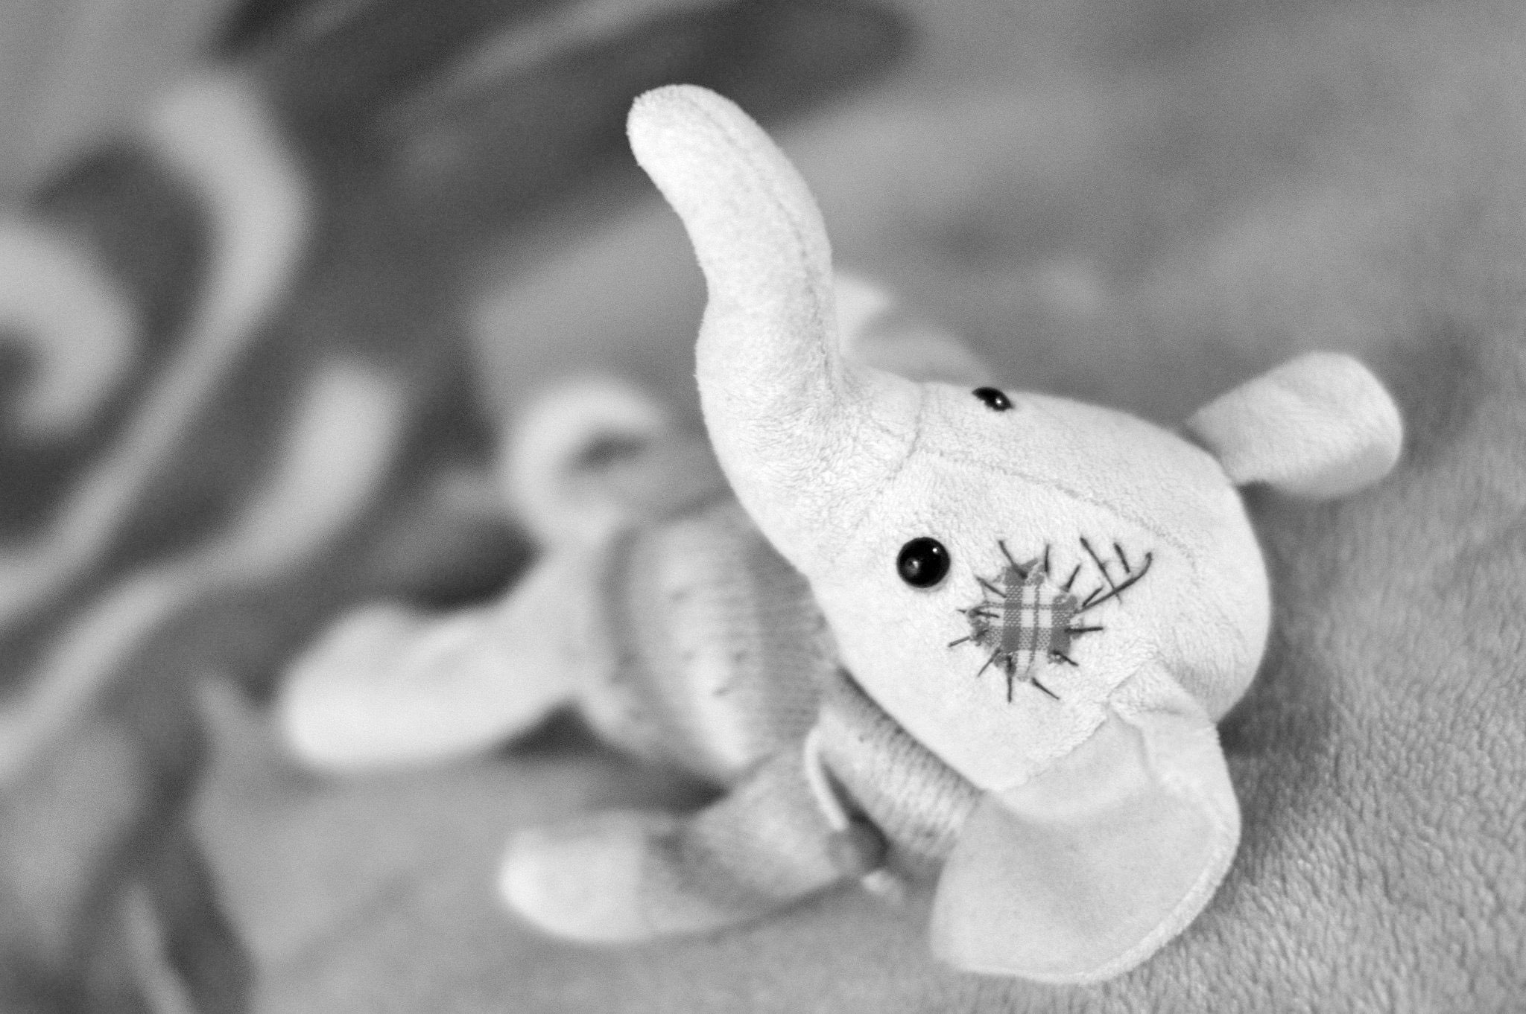
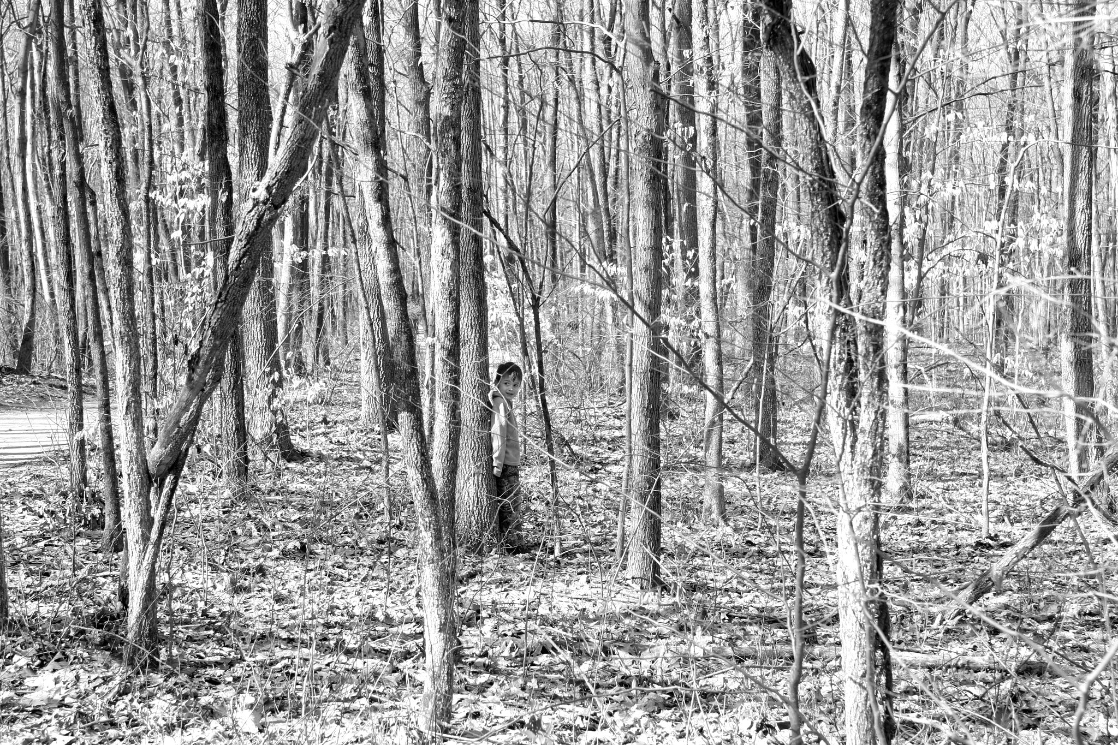
Point to any of these pictures and ask a partner “Does this photo remind you of anything from your childhood?”

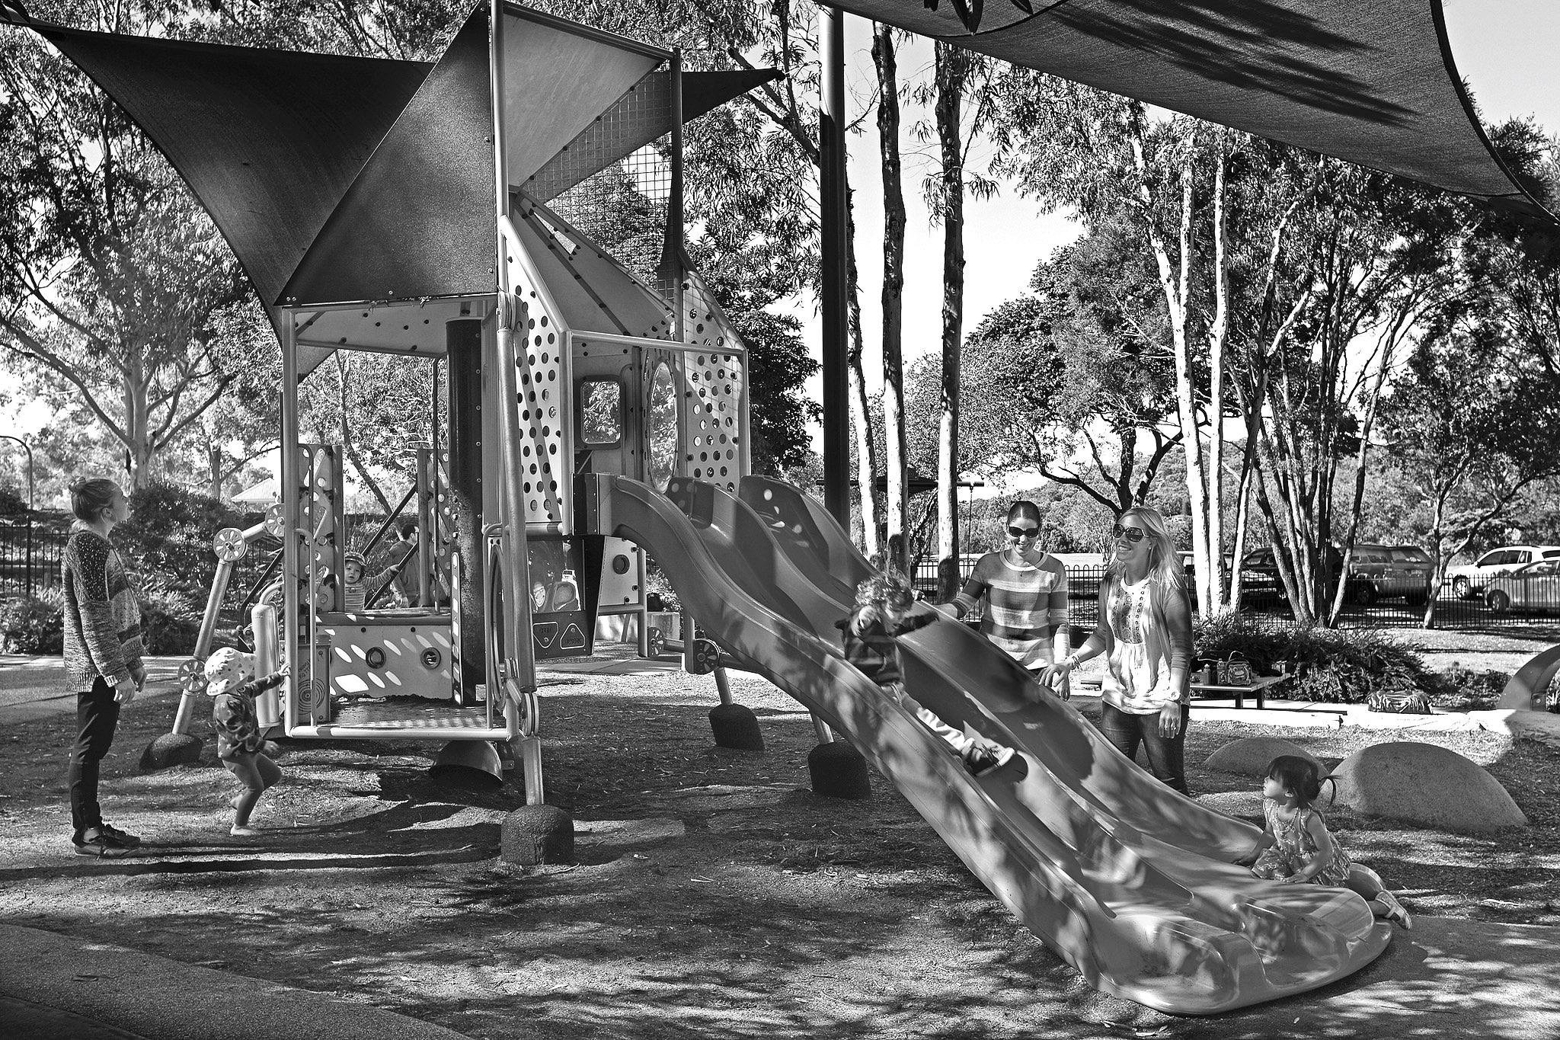
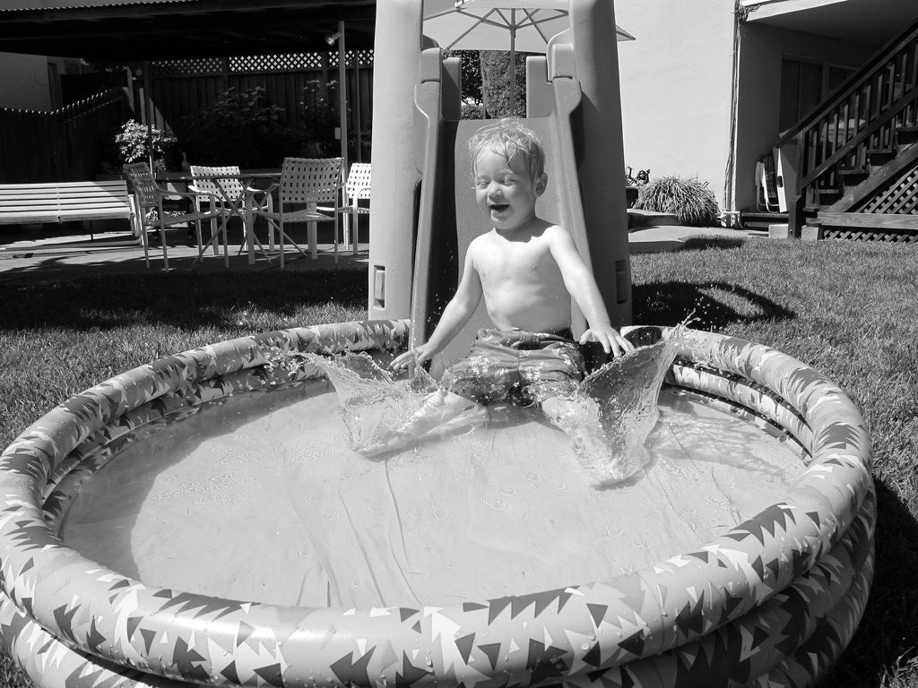

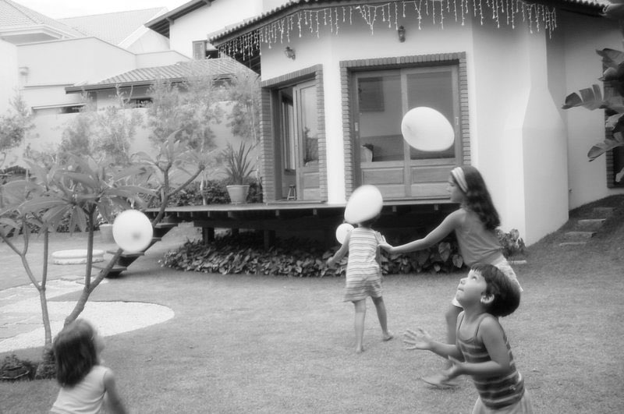
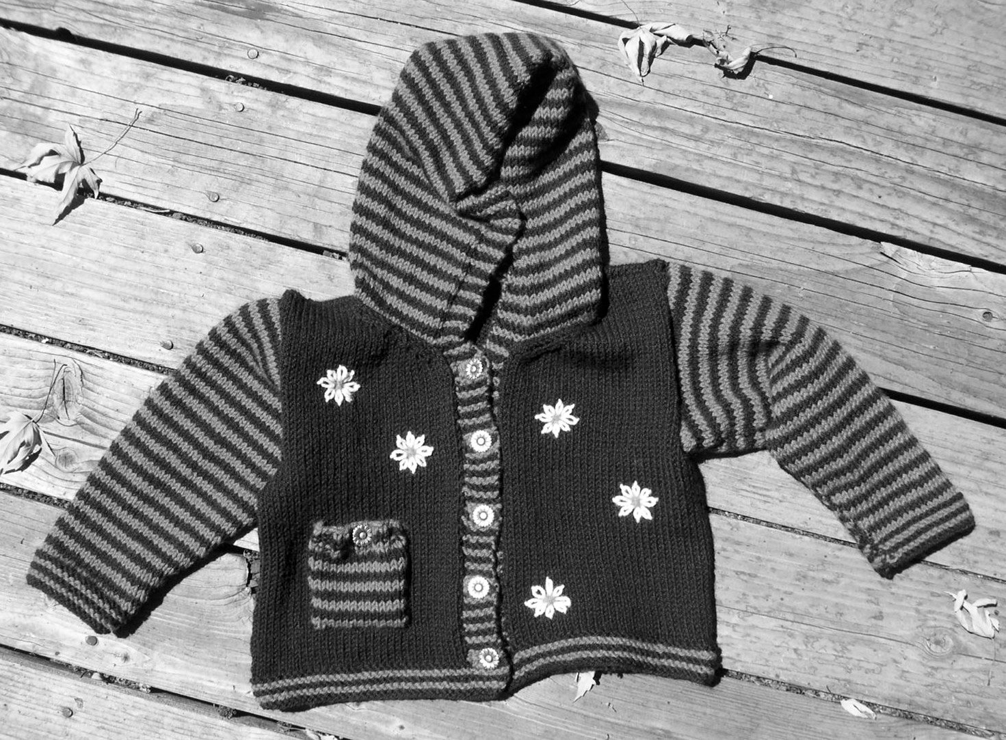

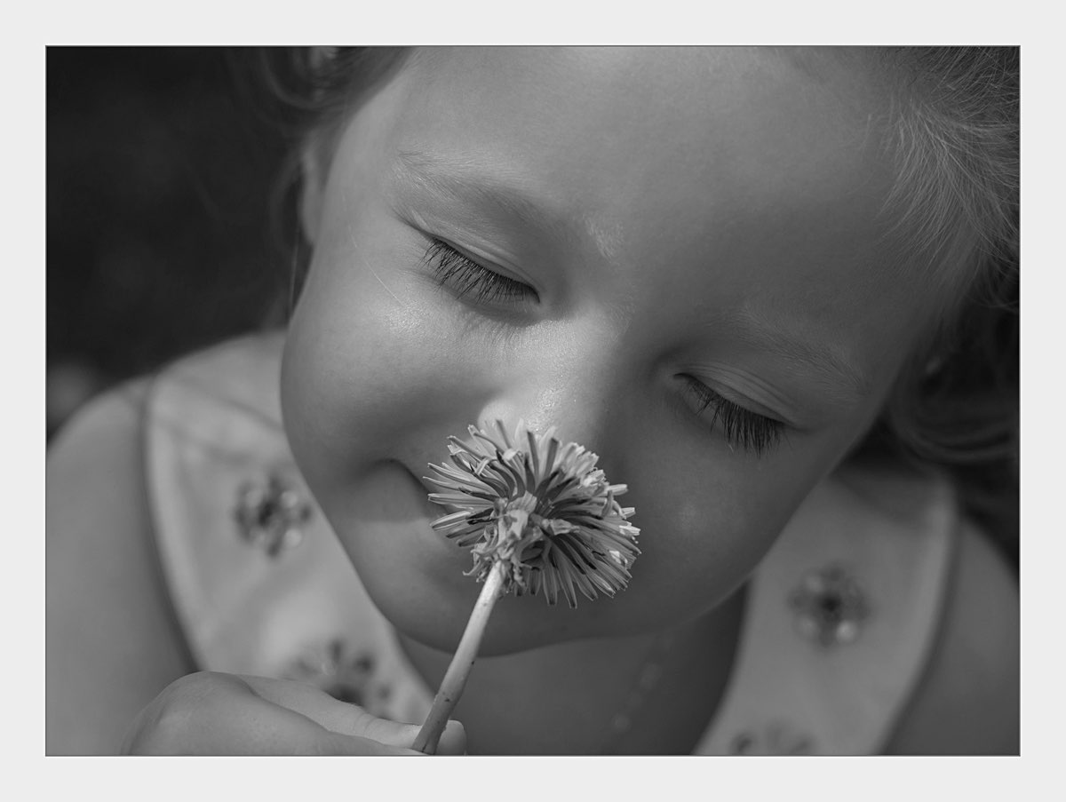
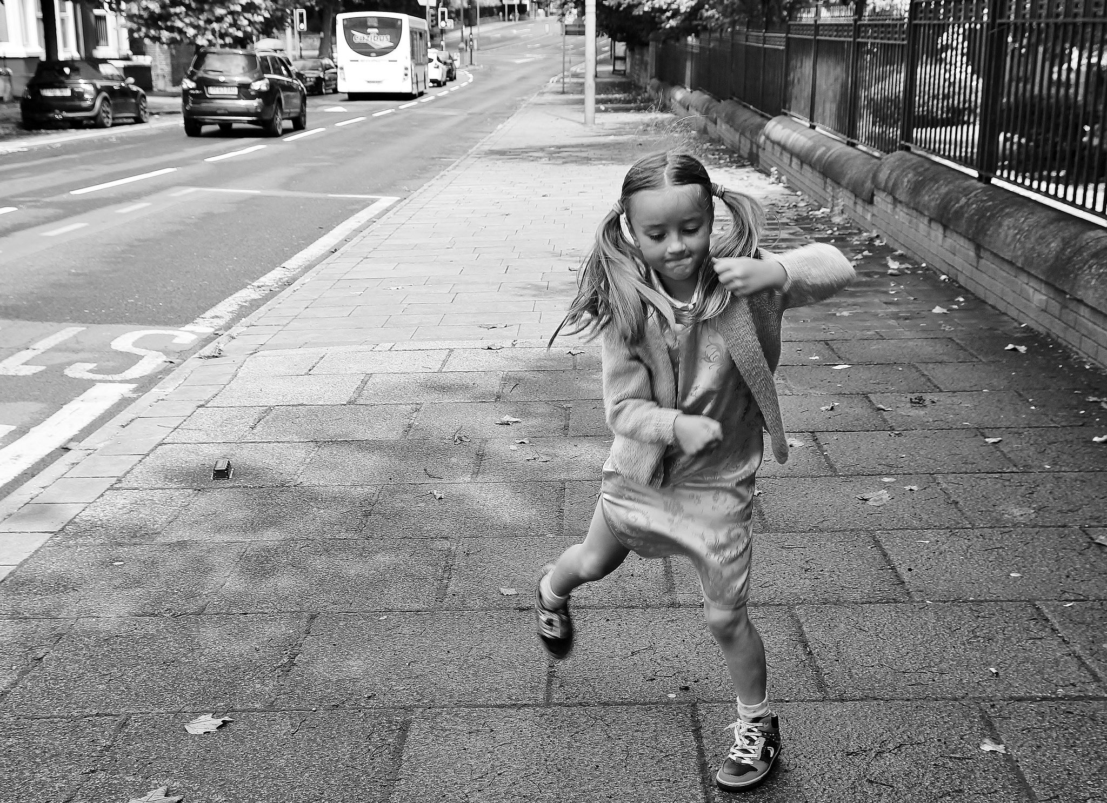
Photo Credits On Flickr: Stacy Brunner, Hiding. Maria Burity, Childhood. Ivan, Childhood. Summer. Lisa Dusseault, Childhood Daisies. Alison Bonbon, Off to Tate Liverpool. The Mighty Tim Inconnu, Joy of Childhood. Playground, Brisbane City Council. trollmannen8, DSC_4669

